**Abdominal Organs**

The below article is taken from <https://medlineplus.gov/ency/presentations/100049_1.htm>

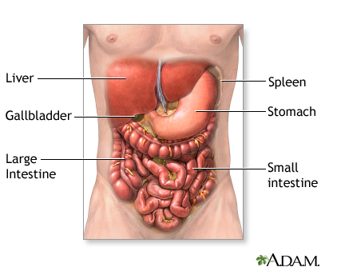

The abdomen contains many vital organs: the stomach, the small intestine (jejunum and ileum), the large intestine (colon), the liver, the spleen, the gallbladder, the pancreas, the uterus, the fallopian tubes, the ovaries, the kidneys, the ureters, the bladder, and many blood vessels (arteries and veins).